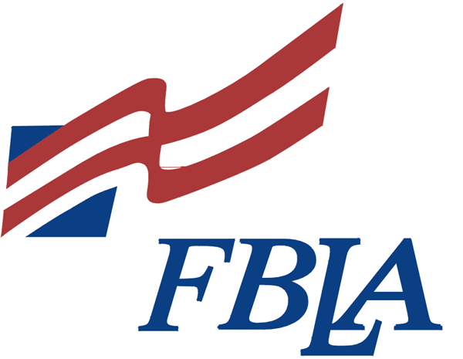
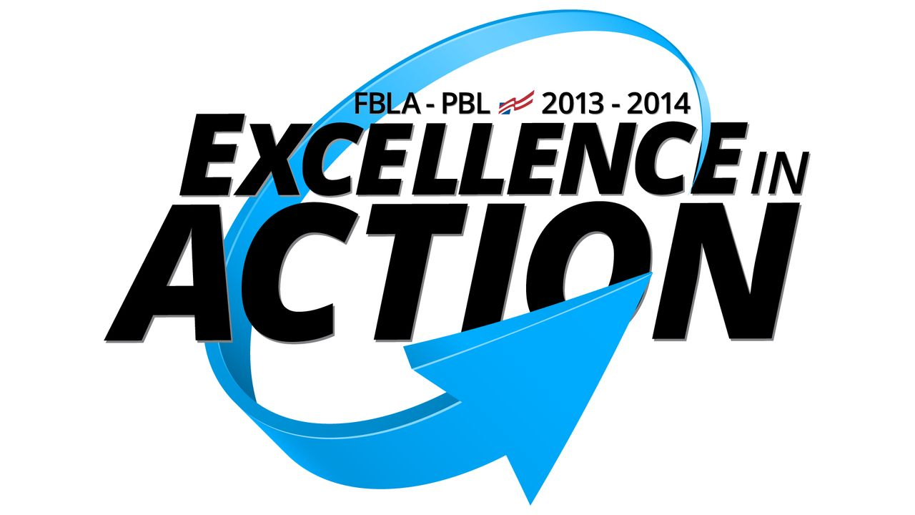

FBLA Member Requirements

- Competitive Events
Each member will sign up to compete in one competitive event; you cannot sign up for your event until you have paid your dues. You will be required to spend at least 3 hours studying/preparing for your event during study sessions in room 100 after school. Your study time must be completed at least one week before your online test in December, do not wait until the last minute to start studying!
Add: you will not be able to take your test or attend the RLC if you do not complete your study time.

- Dues - $25
$6 National, $6 State, $5 Local and $8 for lunch at Regional Leadership Conference at Pennsylvania College of Technology
(can make check payable to BHS FBLA)

- Dress Code & Code of Conduct (on back)
All members are required to dress according to the FBLA dress code and follow the code of conduct at all FBLA conferences.

- Community Service
Bake Sale at BHS Craft Fair  Saturday, Nov. 30th  10 a.m. – 4 p.m. | Tree Fest at Caldwell Consistory  Fri. Nov. 29th, Sat. Nov. 30th, Sun. Dec. 1st  Fri. Dec. 6th, Sat. Dec. 7th, Sun. Dec. 8th
*sign up now in room 100

- Where to Find FBLA Information
- Bulletin board across from room 100
- BHS FBLA website: Bloomsburg High School homepage – Activities – FBLA
- PA FBLA website http://www.pafbla.org

- Conference Dates
January 9th, 2014 Regional Leadership Conference at Penn College of Technology
April 7-9, 2014 State Leadership Conference in Hershey
June 2014 National Leadership Conference in Nashville, Tennessee
CODE OF CONDUCT
One of the goals of FBLA is to facilitate the transition from school to work. Individual conduct and appearance are a part of that training. It is a special privilege to attend an FBLA conference, and it is the responsibility of all delegates to conduct themselves in a proper, businesslike manner at all times. FBLA members have an excellent reputation. Delegate conduct at every FBLA function should make a positive contribution to the reputation that has been established.

Traditional business attire is required for all general sessions, competitive events, caucusing, workshops, meal functions, and receptions. Attire for social functions shall be listed in the conference program. Delegates shall abide by the dress code established by the PA FBLA Board of Directors for all state functions. Delegates not adhering to the dress code shall not be admitted to the functions listed above.

DRESS CODE

Permitted for Gentlemen
Business suit with collar dress shirt, and necktie or
Sport coat, dress slacks, collared shirt, and necktie or
Dress slacks, collared shirt, and necktie.
Banded collar shirt may be worn only if sport coat or business suite is worn.
Dress shoes and socks

Permitted for Ladies
*dresses and skirts shall be no shorter than 1 inch above the top of the knee
Business suit with blouse or
Business pantsuit with blouse or
Skirt or dress slacks with blouse or sweater or
Business dress or
Dress capris (below the knee) or dress gauchos (below the knee) with a coordinating jacket.
Dress shoes and nylons
- note, not off the shoulder tops are permitted

NOT Permitted for Ladies and Gentlemen
Jewelry in visible body piercing, other than ears.
Denim or chambray fabric clothing of any kind, overalls, shorts, skorts, stretch or stirrup pants, exercise or bike shorts.
Backless, see-through, tight-fitting, spaghetti straps, strapless, or extremely short or low-cut blouses/tops/dresses/skirts.
T-shirts, Lycra, spandex, midriff tops, tank tops; bathing suits.
Sandals, athletic shoes, industrial work shoes, hiking boots, bare feet, or over-the-knee boots.
Athletic wear, including sneakers.
Hats or flannel fabric clothing.
Bolo ties.
Visible foundation garments.
Cargo pants

